How to upgrade Qualcomm unit Android 9.0 to Android 10.0
Foreword:
DO NOT RUN THIS RECOVERY guide if your unit is not a Qualcomm 9.0system! It will not work for 4.4 7.1 8.1 or PX6 units. It can crash and break your unit attempting to run it on any of those systems.

Requirement: SDCard or USB flash drive 32GB or smaller formatted FAT32 to complete the update

Please follow these two files to complete two updates：
- Ksw-P-Userdebug_OS_v1.2.0-ota.
https://drive.google.com/file/d/1wf1F5DELJfsdf2K02uwoakR51Tbh4HLX/view?usp=sharing
You need to use Ksw-P-Userdebug_OS_v1.2.0-ota. to update first.
- Ksw-Q-Userdebug_OS_v1.3.0-ota.
After successfully completing the first update, please update with
Ksw-Q-Userdebug_OS_v1.3.0-ota.
https://drive.google.com/file/d/13YzsHj__Io88Z1kduXXQkFcFr94Pg2cG/view?usp=sharing
Note: Please follow the files above step by step, which means that you must update the first file before updating the second.

Upgrade steps:
①Download the Ksw-P-Userdebug_OS_v1.2.0-ota.
Copy the files Ksw-P-Userdebug_OS_v1.2.0-ota.to an empty SD card or USB flash drive.
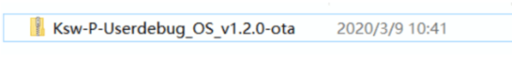

②Insert the USB flash drive with the Ksw-P-Userdebug_OS_v1.2.0-ota. into any USB port of the monitor as shown below:↓

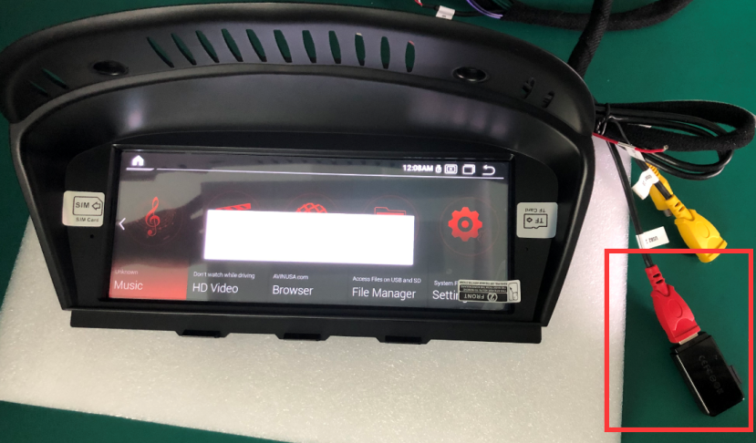
③ After you inserted USB, a dialog box will pop up asking if you want to upgrade and click Yes. Please note that the dialog box sometimes delays for a few seconds. Please be patient.
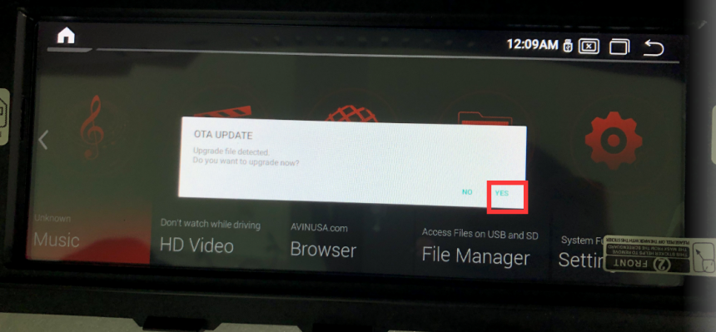
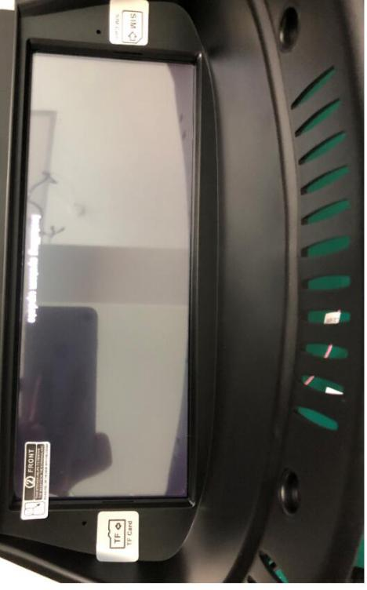

Wait for the unit to update automatically.
⑤ After the update is completed, it will return to the main interface, and a dialog box will pop up again asking if you want to upgrade and click NO.
⑥ Please check if your system information version is changed to Ksw-Q-Userdebug_OS_v1.2.0-ota .
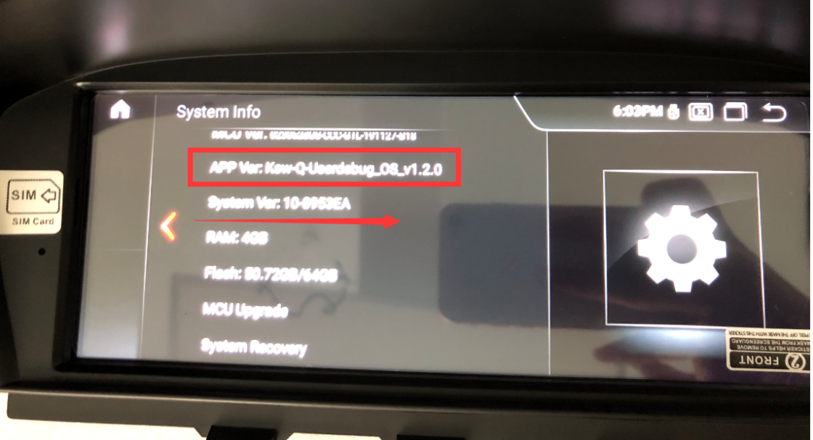
As the photo showed, you have successfully finished your first update.
Now you could remove the USB disk.

Please upgrade the final software：Ksw-Q-Userdebug_OS_v1.3.0-ota.

When you copy this file, please delete all the files in your flash drive, including the previous update files.
（The same upgrade steps as the first software upgrade ）
①Download the Ksw-Q-Userdebug_OS_v1.3.0-ota..
Copy the files Ksw-Q-Userdebug_OS_v1.3.0-ota.to an empty SD card or USB flash drive.
②Insert the USB flash drive with the Ksw-Q-Userdebug_OS_v1.3.0-ota. into any USB port of the monitor as shown below:↓
③ After you inserted USB, a dialog box will pop up asking if you want to upgrade and click Yes. The dialog box sometimes delays for a few seconds. Please be patient.
④The unit will restart and the screen will show: Installing system update.
Wait for the unit to update automatically.
⑤ After the update is completed, it will return to the main interface, and a dialog box will pop up again asking if you want to upgrade and click NO.
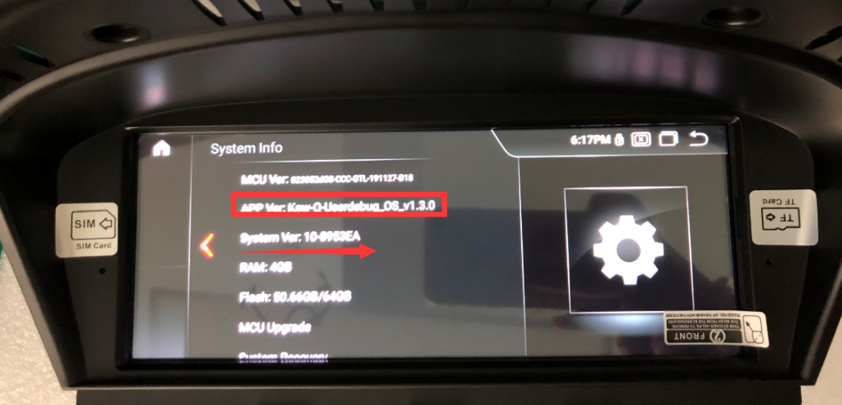
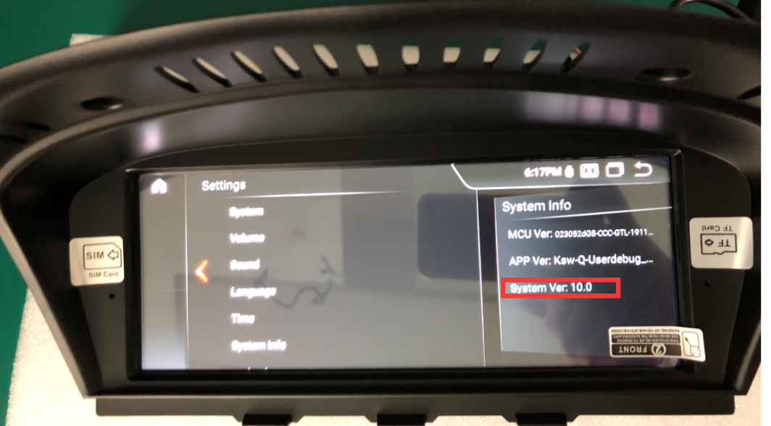
Please check the system information after the successful upgrade, if it is shown as same as above, you have finished the whole complete update now successfully.
Now you could remove the USB disk.

Note:
9.0 upgrade package naming rules：Ksw-P-Userdebug_OS_vx.x.x-ota.zip ( x means version number)
10.0 upgrade package naming rules：Ksw-Q-Userdebug_OS_vx.x.x-ota.zip ( x means version number)
Note the difference between the letters P and Q in the two file names. Upgrade file P. first and then file Q. This order cannot be wrong.
After updating to Android 10.0, the Bluetooth feature of some devices needs to be activated before it can be used. Please connect your mobile hotspot (4G or WIFI) to enable Bluetooth function.

